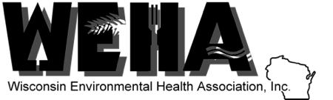
Announcing
Announcing the REHS/RS Exam Review Course in Milwaukee!!

Good Day REHS/RS Candidates:
WEHA Treasurer Brian C Hobbs, RS, and
WEHA Southeast Vice President Lindy Wiedmeyer, BS, MPH, are proud to announce that WEHA is Co-Sponsoring this year's REHS Exam Review Course in Milwaukee, WI.
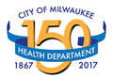
October 2, 3, & 4, 2018 at the
City of West Allis Library’s Constitution Room
7421 W National Ave, Milwaukee, WI
Actual Course hours: 8 am to 5 pm each day
Doors open at 7:30 am each day
You can register at: www.RegisteredSanitarian.com.

Class includes: 3 full days in instruction and coaching, course workbook, example questions, lunch each day, snacks at all breaks. The Exam will NOT be administered.
To review the class syllabus click here: SYLLABUS .
This class is limited to 30 candidates. Register early to secure your space!
If you cannot register with a credit card online you can forward a Purchase Order to Walter@RegisteredSanitarian.com. Or you can mail a check to the address below:
Saraniecki Institute for Nutrition & Environmental Health, Inc
11229 Timberview Lane, Indian Head Park, IL 60525, 773-330-1983 mobile/text
If you sign up with a check be sure to secure a seat in the class by notifying us that your check is in the mail at: walter@RegisteredSanitarian.com .
If you are unable to attend, or have successfully passed your exam; please forward this message to colleagues who may be interested in advancing their professional career.
For more information, please visit the course website: www.RegisteredSanitarian.com .

Hope to see you in Milwaukee!
Regards,

Brian, Lindy, Walter & Claudia

